PIZZA SALES SQL QUERIES
- Total Revenue:
select sum(total_price) as Total_Revenue from pizza_sales;

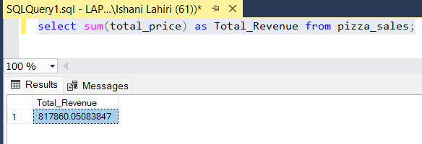

- Average Order Value:
select sum(total_price)/ count(distinct order_id) as Average_Order_Value
from pizza_sales;

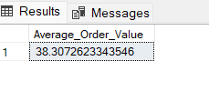

- Total Pizza Sold:
select sum(quantity) as Total_pizza_sold from pizza_sales;

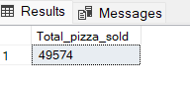

- Total Orders:
select count(distinct order_id) as Total_Orders from pizza_sales;

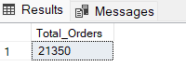

- Average Pizza per Order:
select cast(cast(sum(quantity) as decimal(10,2)) / cast(count(distinct order_id) as decimal(10,2)) as decimal(10,2)) as Avg_pizza_per_Order from pizza_sales;

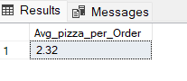

- Daily Trend for Total Orders: Distinct no of orders, over the weekdays (Mon-Sun)

select datename(dw, order_date) as order_day, count(distinct order_id) as Total_orders
from pizza_sales
group by datename(dw, order_date)

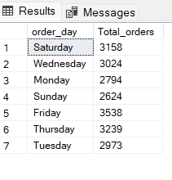

- Monthly Trend for Total Orders: Peak of months of orders being placed
select datename(month, order_date) as order_month, count(distinct order_id) as Total_orders
from pizza_sales
group by datename(month, order_date)
order by Total_orders desc

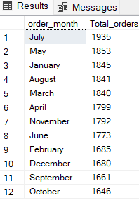

- Percentage of Sales by Pizza Category: Overall sales contribution based on category of pizza
select pizza_category, round(sum(total_price) * 100 / (select sum(total_price) from pizza_sales),2) as Total_sales
from pizza_sales
group by pizza_category

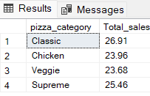
NOTE: If the above table is filtered on the basis of month suppose January, then;

select pizza_category, sum(total_price) * 100 / (select sum(total_price) from pizza_sales where month(order_date) = 1) as Total_sales
from pizza_sales
where month(order_date) = 1
group by pizza_category

NOTE: If the above table is filtered on the basis of quarter suppose Q1, Q2, Q3 or Q4, then;

select pizza_category, sum(total_price) * 100 / (select sum(total_price) from pizza_sales where datepart(quarter,order_date)= 4) as Total_sales
from pizza_sales
where datepart(quarter,order_date)= 4
group by pizza_category

- Percentage of Sales by Pizza Size:
select pizza_size, round(sum(total_price) * 100 / (select sum(total_price) from pizza_sales),2) as percentage_sales
from pizza_sales
group by pizza_size
order by percentage_sales desc;

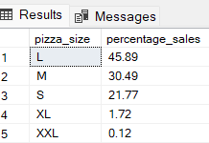

- Total Orders by Pizza Category:
select pizza_category, sum(quantity) as no_of_pizza_sold
from pizza_sales
group by pizza_category
order by no_of_pizza_sold desc;

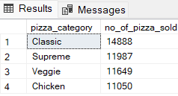

- Top 5 Pizza’s by Revenue:
select top 5 pizza_name, sum(total_price) as Total_revenue
from pizza_sales
group by pizza_name
order by Total_revenue desc

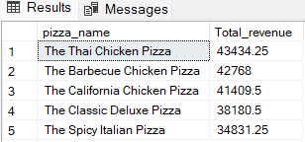

- Bottom 5 Pizza’s by Revenue:
select top 5 pizza_name, sum(total_price) as Total_revenue
from pizza_sales
group by pizza_name
order by Total_revenue asc
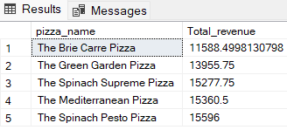
- Top 5 Pizza’s by Qty:
select top 5 pizza_name, sum(quantity) as Total_Qty
from pizza_sales
group by pizza_name
order by Total_Qty desc

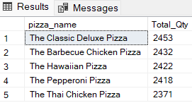

- Bottom 5 Pizza’s by Qty:
select top 5 pizza_name, sum(quantity) as Total_Qty
from pizza_sales
group by pizza_name
order by Total_Qty asc

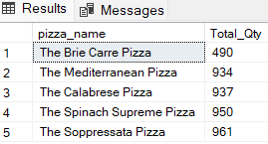

- Top 5 Pizza’s by Total Orders:
select top 5 pizza_name, count(distinct order_id) as Total_Orders
from pizza_sales
group by pizza_name
order by Total_Orders desc

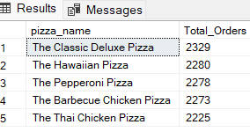

- Bottom 5 Pizza’s by Total Orders:
select top 5 pizza_name, count(distinct order_id) as Total_Orders
from pizza_sales
group by pizza_name
order by Total_Orders asc

